Dominika's Kitchen

This website is all about cooking and baking. There will be plenty of different types of meal with suitable replacements for allergies, gluten free or food preferences, like vegetarian vegan. At the end of each recipe it will show how the food can be presented to make it look more appealing to the eye.

**UX**

This website will be aimed at anyone who wants to find new recipes to spice up their cooking. This will provide inspiration for dinners, lunches desserts and everything in between. The end goal for the user is to cook and enjoy the recipes provided on this website. The user will expect to find a specific meal type or type of food easily. When preparing each meal that will be added to the website, I will create different batches to see how different they are, meaning add more of one thing and then in another batch cook differently. This will be documented and will show the user that for example adding too much of butter will make the cake fall and become more greasy than desired. This is what will make my website stand out from others, all the differences will be documented, not in a boring all text type of way though.

When the user first enters the page they will immediately know what the website is, and will be able to follow the natural way and how to navigate it. The key things in the navigation bar will be types of meals, so breakfast, lunch, dinner and desserts. If I was to fully develop this website, I would like to have a paging system where the user would follow from one page onto the next, to browse recipes and add a filter that would only show the wanted recipes. For example a vegan filter where it would only display vegan recipes.

The whole website will have the same theme through out all the pages, following the in-house theme of the whole website.

**Features**

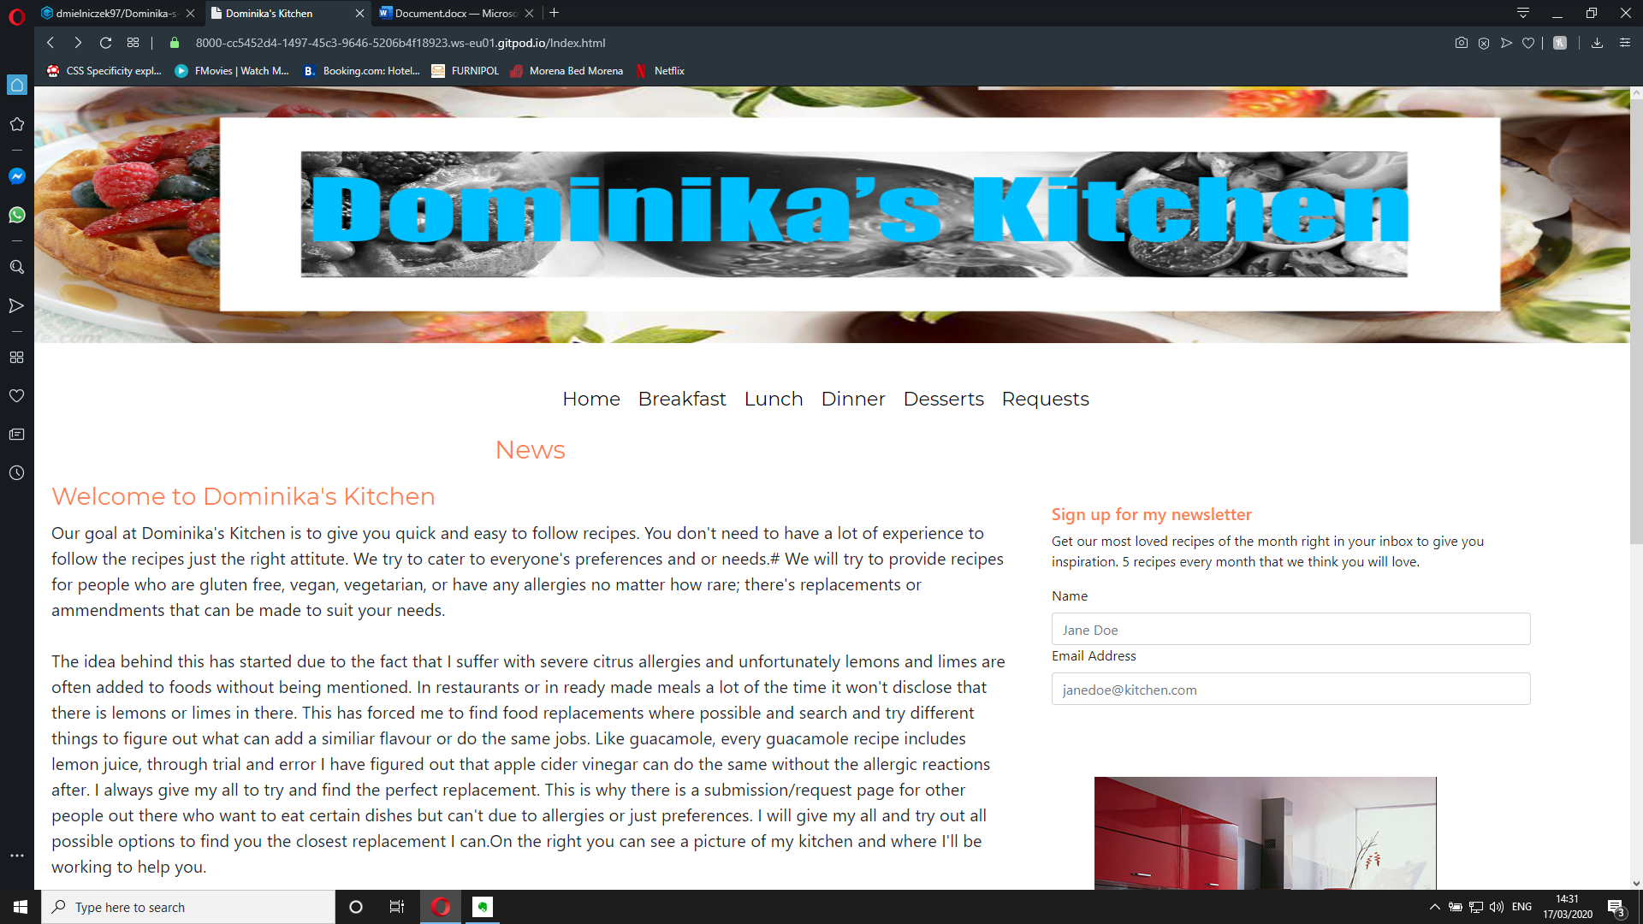

This is what the home page looks like when you enter the website, it would have all the news that would be updated weekly as the main article. At the top is the website banner which is part of the standard that will be followed throughout the website, along with the navigation bar. They will both remain static on every page of this website to make it easy and clear to the user where they are and what they are doing. On the side you have the option to subscribe to the newsletter and a picture of the kitchen to make the viewer feel like they know you and be able to relate to you because you’re making it personal. The footer with all the icon logos will also be the same throughout the whole website, to follow the theme and keep the user used to seeing the same things on every page. The icons will all change color when hovered over and will take you to the social media page of your choosing to show the profile and allow you to easily interact with the profile owners.

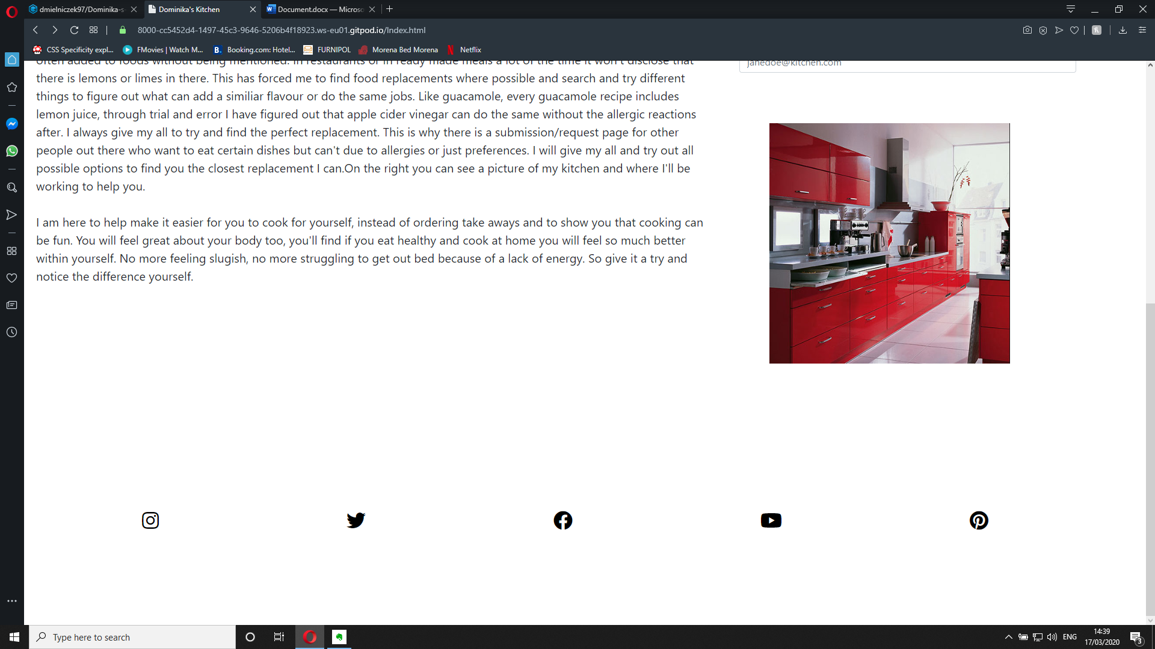

The navigatation will also follow suit in being the same throught out the website. It’s black writing on the plain white background, when hovered over has a coral colour which is in theme with everything else.The navigation links will lead you from page to another seamlessly without having to use the backarrow button for anything. The navigation is clear and a good size to not take up too much room on the page but be visible to the user. This is the last feature that’s used to create a standard page. The banner, navigation bar and the footer.

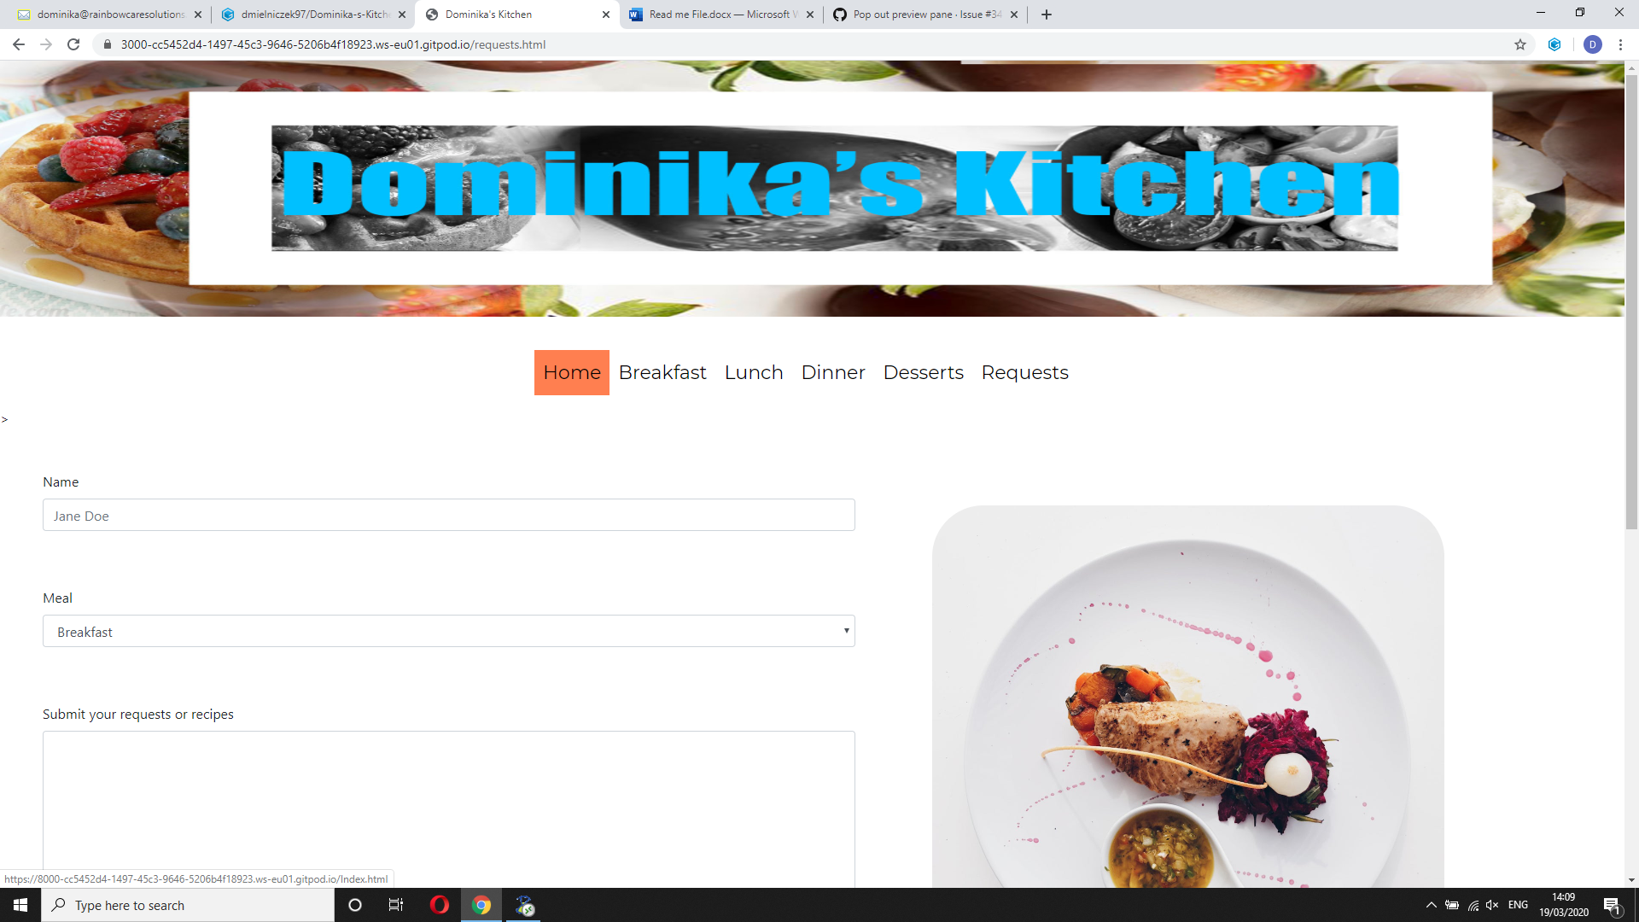

**Index.html/Home page**

This page contains an introductory news letter, that will be found on the home page, where that’s the first thing people will see entering the page. Next to it we have the subscribtion option to allow the user to subsribe to the newsletter straight to the email. There is a form that asks for a name and an email. Underneath there is a picture as a gap filler.

**To improve/future ideas**

Ideally I would like replace the picture as a gap filler, instead I would like to have a feed of the social media’s on the right hand side to show the most recent posts on instagram, twitter,pinterest etc. This would encourage the user to go and follow the social media links and interact through that way.

**Breakfast page**

On the breakfast page you have your title, your brief description of the recipe to show a little bit about the recipe. We then have a step by step routine to make it as easy as possible for the user to follow. The goal is for the user to be able to follow the recipe as easy as possible. On the right side you have a picture of the product for the user to see it and be encouraged to make said recipe by the picture looking appealing. Underneath it there is a ingredients list to make it easy for the user to come to the page and see what they need to have to make a shopping list.

**To improve/future ideas**

I would like to have a step by step picture guidance or even better a video of the whole process an underneath it have the steps, in case people wanted to read ingredients or print it out for their home use. With the current view you would have the reicipes follow suit in pages one after the other. To improve I could do a master page with a picture and name of the recipe and then when clicked it would take you to the details of the recipe. I would also love to add a filter where someone can tick certain food preferences. Like vegan, vegetarian or gluten free. I would also like to make it easy for people with rare allergies so you could select any type of food you can’t eat and it would filter recipes with said ingredient out.

**Request page**

On this page we have a form where people can submit their recipes or they can submit requests that they would like a recipe of, for example if they can’t find a recipe without a certain ingredient. I would be able to adapt the recipe to suit their personal needs. On the side there is a filler image.

**To improve/future ideas**

I would like to ideally have an faq on the other side where the filler image is, answering the most commonly asked questions.

**Overall future ideas**

I would like for this website to have all the pages created not just the home,breakfast and request. I would also in future like to add a search bar to allow users to quickly and easily find specific recipes.

**Technologies used-**

Boostrap <https://getbootstrap.com/> – I have used bootstrap to style the request forms and the newsletter subscription form.

Fontawesome <https://fontawesome.com/start> – I have used font awesome to add the social media icons at the footer of the page.

[W3C Markup Validation](https://validator.w3.org/) used to validate HTML.

[W3C CSS validation](https://jigsaw.w3.org/css-validator/) used to validate CSS.

**Deployment**

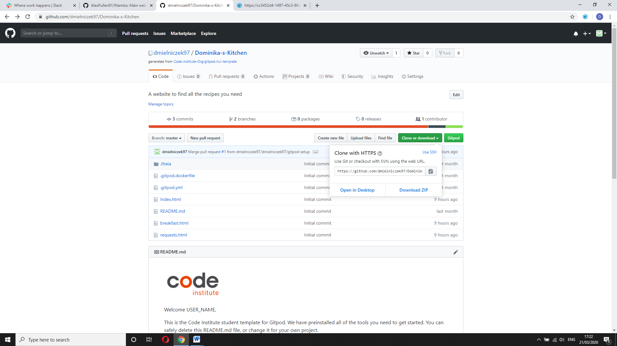I have used gitpod for this project and I submitted it to github. I did so by adding every file one by one and then committing the files to push them through to Github to be hosted. To open the gitpod project locally you can do so by downloading the file to your computer as shown below. You are also able to clone the

**Credits**

All content on the page was written by myself.

The photos I used came from a Google search and from the following websites:

<https://www.wideopeneats.com>

<https://cravinghomecooked.com/>

<https://www.lightspeedhq.co.uk/>

<https://www.delish.com/>

I received inspiration for this project from a couple different websites and aspects of it that I enjoyed. Like the following

<https://www.delish.com/>

<https://tasty.co>